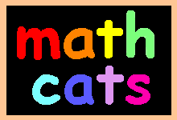 | Connect the Dots | 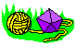

big grid of dots  tiny grid of dots | Connect the dots to make a tessellation (a repeating pattern of shapes which fit together perfectly). Look at the pictures below to get started. There are many many more ways to connect the dots to make repeating patterns. How many ways can you find?
You can make shapes which form diagonal patterns, like these two L-shaped designs. How will your design look with 2 colors? 4 colors? more?

These two designs are formed from the same pattern of cross shapes. Coloring them with two or three colors makes the patterns look different.

These two designs use the same pattern of T shapes and upside-down T shapes. The two colors are arranged in different ways.

---------------------------------------------------------------------------------------------------------------------------------------------------
Here are two more ideas, based on an "S" shape and a "C" shape. The second pattern uses reversed shapes to interlock with the C shapes. How would this pattern look with 2 or 3 colors?

These two patterns connect some of the dots diagonally. The second design uses two different shapes in a repeating pattern. There are many other ways to make a tessellating pattern with two different shapes.

You don't need to fill the whole grid with a pattern. Try coloring part of the grid and then cutting it in an interesting shape.
Hexagrams

#1: basic hexagram | #2: interlocking triangles | #3: six triangles
With a compass, a straight edge, and a pencil, you can make these
hexagram designs and many more. Here's how:
1) Use a compass to draw a circle. Keep the compass set at the same position for the next step.
 | 2) Place the compass point on the edge of the circle and make a faint mark on the edge. Then place your compass point on this mark and make a second mark. Continue around the circle until you have made six marks. They should fit perfectly.
3) Now you will use the straight edge to connect different points. Draw your lines as faintly as you can, because you will be erasing some of these lines later. First, connect opposite points to make three lines which all cross at the center of the circle. Each line cuts the circle exactly in half at its widest point and is called the diameter of the circle.
 | 4) Next, connect every other mark to form a large triangle.
5) Connect the other three marks to form a second, upside-down triangle.
 | 6) Mark the six points where the large triangles intersect (cross) the three diameter lines. Then connect every other mark to form a small triangle.
7) Connect the other three marks to form a small upside-down triangle.
 | Now you have drawn all of the lines needed for making all three hexagram designs at the top of this page. You just need to darken the lines needed for one of the three hexagram designs and erase the remaining pencil lines.
8) Use a straight edge and a dark pencil, colored pencil, or pen to trace over just the lines needed for this design (the red lines on each diagram). You may also like to look again at the shapes which form each design at the top of this page. | #1: basic hexagram
#2: interlocking triangles | #3: six triangles
This photo shows the outlines of the six triangles, darkened with straight red lines. Notice how faint the remaining lines are.
9) Erase the faint lines which are not a part of the design.
Hint: If you like working with a friend, you can take turns: one person holds the straight edge while the other person draws the lines. That way both of you can make sure the faint lines and the darkened lines are placed exactly right. (It's a little tricky when you are figuring out which lines to darken!)
10) Color your design and cut out the circle.
If you like, you can paste each hexagram design onto a backing of posterboard, cardboard, or foamboard and hang it from a loop of yarn or thread. You could paste a different design on the back and hang several to form a mobile.

Emily and Fatso are very proud of their hexagram!
Extra Challenge: Can you think of some other ways to outline and color to make a different kind of hexagram design? For instance, the three hexagrams pictured at the top of this page all have empty centers. Can you create a design which uses some or all of the tiny shapes in the center? Can you and your friends or classmates each create a unique design? How many lines of symmetry does your design have?

© copyright 2001 - 2013 by Wendy Petti of Math Cats. All Rights Reserved.

Materials  - 1 box of toothpicks  - 1 sheet of paper  - glue  Instructions  - Using a pencil, make an outline of the building.  - Make a line of toothpicks standing vertically on the bottom. This will be the widest row.  - Glue the toothpicks to a sheet of paper, using lots of glue.  - Line up and glue the remaining rows of toothpicks.  - Let dry completely before picking up.  - Now you can make word problems using the picture. For example:  - How many more toothpicks are there in the first level than in the second level?  - How many more toothpicks are there in the first level than in the third level?  - How many toothpicks are there in levels ___ and ___ ?  - How many toothpicks are there in all?  - If there are 75 offices on level 2, how many offices are there likely to be on level 1? level 4?  - If each floor of the building is 12 feet high, and if there are 5 floors per level of toothpicks, how many floors are there in the building? How tall is the building? | 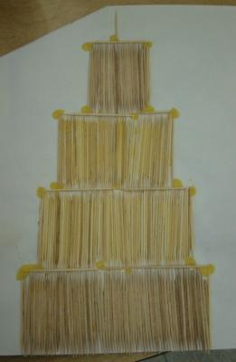  Ideas  - If you like, use a longer sheet of paper and make a taller skyscraper with more levels.  - You might like to color every 10th toothpick to make it easier to count them.
This math craft was created in January 2004 by Donald P., grade 5,
Philip G. Vroom Elementary School, Ms. Geis's class, Bayonne, New Jersey, U.S.

© copyright 2004 - 2013 by Wendy Petti of Math Cats. All Rights Reserved.

Symmetrical Butterflies

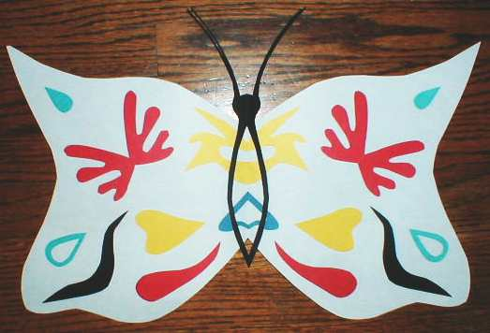
On a symmetrical butterfly, each half is a mirror image of the other.
To make matching pairs of shapes:
1. fold paper | 2. cut | 3. check your pair | 4. arrange and glue

You can also make a "doubly symmetrical" butterfly
in which each smaller shape is symmetrical:
1. Make a fold in each sheet of colored paper. (Place the long edges together, then crease.)
2. Fold again.
3. Starting at the bottom of the thick fold, cut a wiggly or zig-zaggy shape that ends a bit higher up on the fold.
4. Unfold the pieces: you will have two identical symmetrical shapes.
5. Repeat for other shapes and colors.
6. Fold a sheet of paper in half and cut out half of a shape of butterfly wings.
7. Glue one set of cutouts on one half of the opened butterfly wings. Carefully arrange the remaining cutouts on the other half of the butterfly so that they match their partners when the wings are refolded. You might want to mark their positions with pencil, then glue them down. Add another symmetrical cutout for the head, antennae and body.
The symmetrical butterfly at the top of the page uses both symmetrical and asymmetrical shapes. It also uses single symmetrical shapes glued at the fold under the body.
Other ideas:
Your outer shape doesn't have to be a butterfly, of course.
Can you decorate two halves of a rectangle or a circle?
Can you make a design with both horizontal and vertical lines of symmetry?
Let's share our ideas. Please send us a photo of your symmetrical shape, and we will post it here!

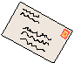
math cats' mailroom

© copyright 2003 - 2013 by Wendy Petti of Math Cats. All Rights Reserved.

