Mobile Games:
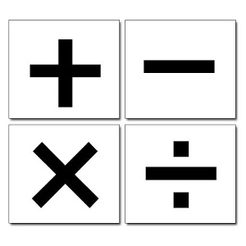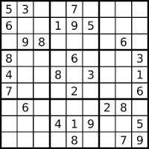
These are some of the mobile games that I would like you to play. You can search for Android Mobile games and download it on your mobiles and play. If you do not have Android based phone, play games on your PC and send me the link. Send a report on your experiences and usefulness in about 100-150 words. If you find any other game please mention the name of the game and what you gained by playing. Play tower of Hanoi game on your computer available online.
- How was the game? Do you like to play on a regular basis?
- How many levels did you reach? Which level was difficult?
- Which game you found it captivating and why?
- How can you relate with your subject learning?
- Share your interesting experience if any.
- You have play games last summer related to your chapters in the prescribed textbook? How helpful was it in deeper understanding of the subject while in school?
- Send at least 10 links of Maths games and 5 videolinks which you found it interesting and useful for your standard.
- Do you think playing games on a regular basis will help you learn concepts better. Give reasons from your experience.
- Make your presentation attractive by inserting pictures(any type of file ppt or wordfile or any other format) and send it to me on my email vasumathyv@gmail.com latest by 12th of December. Consider this as one of the project for the next term. I shall project your work on my website to share it with your friends after 12th December.

All the best. Enjoy doing your work. Happy Holidays. Wish you all a very Happy New Year.

This file will be present on my website activemath.weebly.com on the homepage.

