Mathematics test winter coaching 2019 ( December 8)
Marks:30
Time: 1 hour

- Mrs. Geeta deposited 350 per month in a bank for 1 year and 3 months under the Recurring Deposit Scheme. If the maturity value of her deposits is 5,565; find the rate of interest per annum. (3)
Instalment per month(P) = Rs350
Number of months(n) = 15
Let rate of interest(r)= r %p.a.
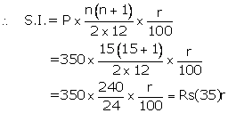
Maturity value= Rs(350 x15)+Rs(35)r
Given maturity value= Rs5,565
Then Rs(350 x15)+Rs(35)r = Rs5,565
35r = Rs5,565 -; Rs5,250
r =

- Mr. Richard has a recurring deposit account in a post office for 3 years at 7.5% p.a. simple interest. If he gets Rs. 8,325 as interest at the time of maturity, find:
i. the monthly income
ii. the amount of maturity (4) Let the monthly deposit be P
Interest = Rs. 8,325
Rate of interest = 7.5%
Time = 3 years = 36 months
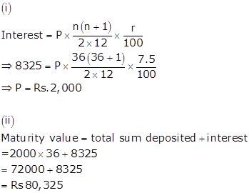

- A dealer X in Hapur (U.P.) supplies goods/services, worth Rs. 50,000 to some other dealer Y in the same city. Now the dealer Y supplies the same goods/services to dealer Z in Calcutta at a profit of Rs. 20,000. Find
i. Output and input taxes for the dealer Y
ii. Net GST payable by dealer Y.
The rate of GST at each stage is 28% (5) For the dealer X (intra-state transaction)
SP = Rs. 50,000

For the dealer Y (intra-state transaction)
CP = Rs. 50,000
CGST = 14% of 50,000 = Rs. 7,000
SGST = 14% of 50,000 = Rs. 7,000
Input tax for dealer Y = Rs. 14,000
Profit = Rs. 20,000
SP = Rs. 70,000

For the dealer Z (inter-state transaction)
CP = Rs. 70,000
IGST = 28 % of Rs. 70,000 = 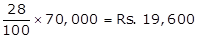
∴ Input Tax = Rs. 19,600 which is the output tax for dealer Y.

Net GST payable for Y
= Output tax for Y - Input tax for Y
= 19,600 - 14,000
= Rs. 5600

The marked price of an article is Rs. 6000. A wholesaler sells it to a dealer at 20% discount. The dealer further sells the article to a customer at a discount of 10% on the marked price. If the rate of GST at each stage is 18%, find the amount of tax (under GST) paid by the dealer to the government. (4)
Initial marked price by manufacturer A is Rs. 6000
B bought the T.V. at a discount of 20%.
Cost price of B = 80% of 6000 = Rs. 4800 ….(i)
GST paid by B for purchase = 18% of 4800 = Rs. 864 ….(ii)
B sells T.V. at discount of 10% of market Price
Selling price for B = 6000 - 10% of 6000 = Rs. 5400 …(iii)
GST charged by B on selling of T.V. = 18% of 5400
= Rs. 972 …(iv)
GST paid by B to the government
= GST charged on selling price - GST paid against purchase price
= 972 - 864
= Rs. 108

- Solve the following inequation, write the solution set and represent it on the number line.
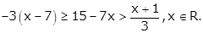 (4)

6. A man buys 400, twenty-rupee shares at a premium of Rs4 each and receives a dividend of 12%. Find:
(i) the amount invested by him.
(ii )his total income from the shares.
(iii) percentage return on his money (4)

- The sum of the heights and the radius of a solid cylinder is 35 cm and its total surface area is 3080 cm², find the volume of the cylinder. (3)

Solution 21
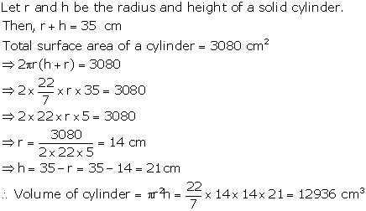

- A solid metallic hemisphere of diameter 28 cm is melted and recast into a number of identical solid cones, each of diameter 14 cm and height 8 cm. Find the number of cones so formed.
(3)

Solution 9
Volume of the solid hemisphere
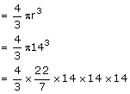

Volume of 1 cone
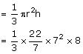

No. of cones formed

